Pre-Assessment Questionnaire

“Ensuring we understand as much about your health and wellbeing as you do.”

Name |  | Email
Address |  | Mobile No
 |  | GP name
 |  | Address
Postcode
DOB

Your Current Medical History

Y | N | Are you taking any regular medication?........
Y | N | Are you Diabetic? ………
Y | N | Do you have Cardiac/Heart problems?.........
Y | N | Do you have Epilepsy?........
Y | N | Do you have Asthma or any other Respiratory problems?......
Y | N | Have you been diagnosed with osteoporosis?.......
Y | N | Do you have any joint replacements?........
Y | N | Have you noticed any bladder or bowel dysfunction?......
Y | N | Have you noticed any sudden unexpected weight loss?
Y | N | Have you been diagnosed with any form of cancer?......

Please use the box below if you require more space.

What is the main reason for requiring treatment?

Visual Analog Scale

Mark an X on the line to show the level of your pain

No pain |-----------------------------------------------------------------------------------------------------------------------| worst pain possible

Please mark with an X the area you experience pain.

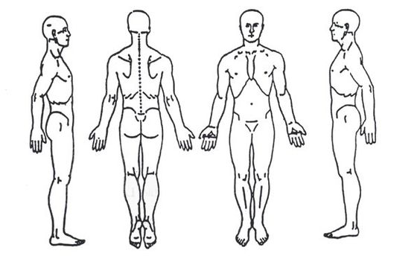

List any activities that make the problem worse.

List any activities that make the problem better.

What are your goals/hopes in attending physiotherapy treatment?

Thank you for choosing to have physiotherapy treatment at Physio 4 Wycombe.

It is our aim to provide the highest quality clinical care, focusing on treating the cause & not just the symptoms. We take time to get to know you & your condition before treatment commences & then teaching you how to help reduce the possibility of recurrence.

During a physiotherapy appointment the physiotherapist will perform a physical assessment. This will involve taking a history, movement analysis, specific tests which may increase or decrease your symptoms. You may also be asked to undress to an appropriate level to enable a thorough examination. You will never be in a situation where you will feel embarrassed or uncomfortable by this process – if you do please let us know.

Physiotherapy should reduce your discomfort. However, certain treatments may initially increase your pain prior to it decreasing. Consequently, it is not uncommon to feel an increase in pain & soreness later the same or following day. If you are worried or concerned, then please contact us immediately.

Treatment recommendations may include but are not limited to manual therapy, manipulation, acupuncture, therapeutic ultrasound, taping, advice & exercises.

During your appointment you are welcome to be accompanied by a chaperone. Patients under 16 years MUST always be accompanied by a parent/guardian.

If at any time during your appointment you are unhappy or uncomfortable you may ask the physiotherapist to stop at any time.

Fees

Prior to commencing your treatment, we will need you to confirm how you intend to pay for your treatment.

Private Health Insurance

We can claim directly from your insurer on your behalf. We are recognised by all the main Medical Insurance Companies. Our invoice should be settled within 30 days of the invoice date. If your insurance company delays settlement you may be asked to settle the invoice. It is your responsibility to follow your insurance company’s referral procedure. You must be aware of your level of cover and whether an excess applies. If you have an excess, you are required to pay the excess after each treatment until the excess has been reached.

Pay as You Go

If you are self-paying fees must be paid after each treatment session.

Our fees are £45 for the initial Consultation/Treatment (45-60 minutes) and £40 for further treatment sessions (30 minutes).

I am responsible for the payment of my own fees Yes

I will authorise my Health Insurance Company to settle my account Yes

YOU MAY BE CHARGED THE COST OF YOUR APPOINTMENT IF YOU FAIL TO ATTEND OR CANCEL AN APPOINTMENT WITH LESS THAN 24 HRS NOTICE.

I hereby acknowledge receipt of the above information and agree to the terms and conditions set out in this form. I consent to aspects of the physiotherapy treatment administered by Fraser N Jackson & Associates at Physio 4 Wycombe. I understand the explanation I have been given as to all the treatment I am to receive and why such treatment is necessary, and I consent to that treatment being given to me. I further understand that I am free to request that the treatment ceases and an explanation be given to me again.

Signed Date

Printed
(IF UNDER 16, MUST BE SIGNED BY GUARDIAN/PARENT)

I give consent to Physio 4 Wycombe to process my personal and sensitive data for the purpose of Physiotherapy treatment and understand my records will be kept safe for the benefit of future treatment.

Signed Date

Printed

